The program does not check the age of the player. As the guiding document, the player must be over 18 years old to play the game. However, the application does not check that.

Below are the evident. As the image showing, there is no variable for player’s age.

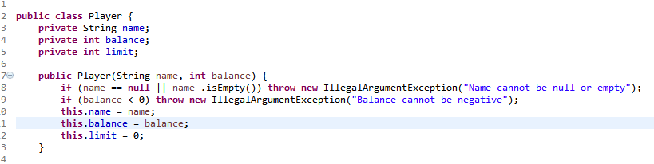

Below is the evident of testing the bug by JUnit Test. As the image showing, the program did not check the age of player.

